12.1 Introduction to Respiratory System

* **External respiration**: respiratory function, exchange of and
  + **Ventilation**: breathing, air exchange between lungs and external environment
  + Diffusion: alveoli ⬄ capillaries
  + Transportation: blood carries and
  + Diffusion: capillaries ⬄ tissues
* Non-respiratory functions:
  + water loss (humidification of alveoli) & heat elimination (from water loss)
  + venous return (respiratory pump)
  + vocalization, smell
  + defecation, childbirth
  + blood reservoir for left heart
* \***Lung**: 3 lobes right, 2 lobes left; cardiac notch (where heart sits) in lower left lobe
  + **Nasal passage > pharynx > larynx > trachea > bronchi > bronchiole > alveoli**
  + Convection, low SA, high speed (need energy) => diffusion, high SA, low speed
  + 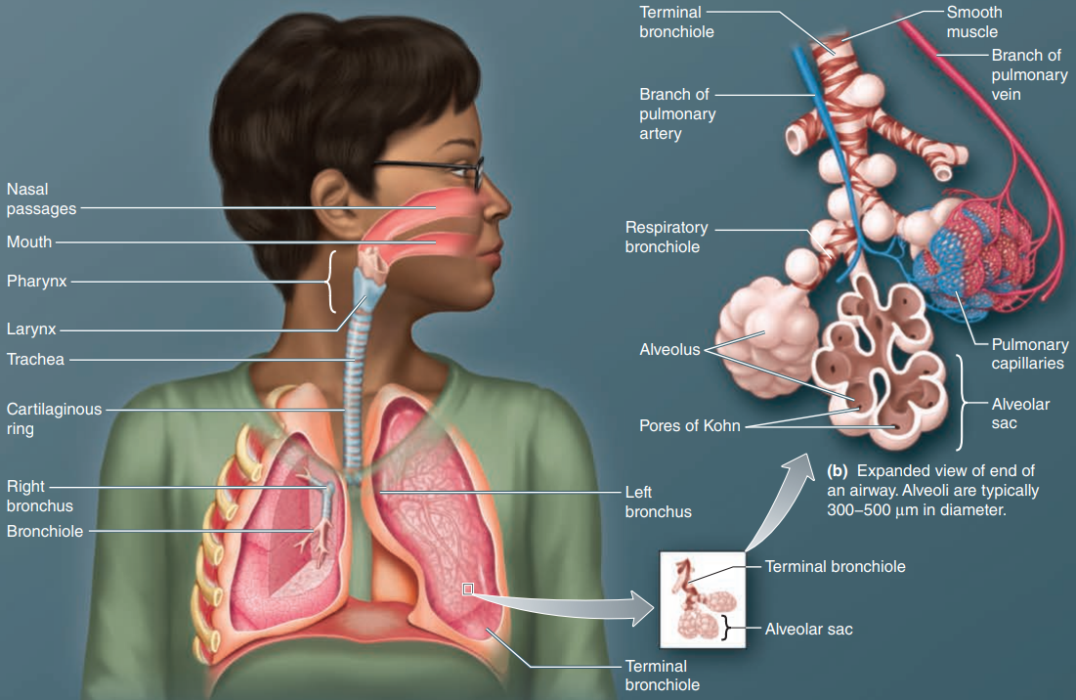Skeletal + smooth => smooth => none
  + Collateral ventilation (between alveoli) via **pores of Kohn** when airway blocked
* **Thorax** (chest wall):
  + 12 pairs of **ribs**; join **thoracic vertebrae** posteriorly, 1–7 join **sternum** anteriorly
  + *Inspiratory muscles: inhale
    - **Diaphragm**: innervated by phrenic nerves (C3-5), 50-70% of enlargement
    - External intercostal muscles: between ribs, stabilize the chest wall
  + *Expiratory muscles: exhale
    - Internal intercostal muscles: between ribs, inside external intercostal
    - Abdominal muscles: only when exercising (active expiration)
  + \***Pleural space**: space between two parietal membranes on thorax and lung, contains **pleural fluid** (lubrication)

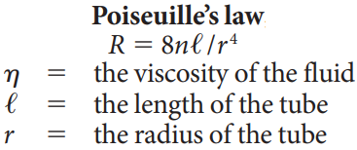12.2 Respiratory Mechanics

* flow = pressure/resistance, , 4 pressures
  + atmospheric or barometric pressure
  + alveolar pressure
  + pleural pressure
  + transpulmonary pressure / lung recoil pressure
* 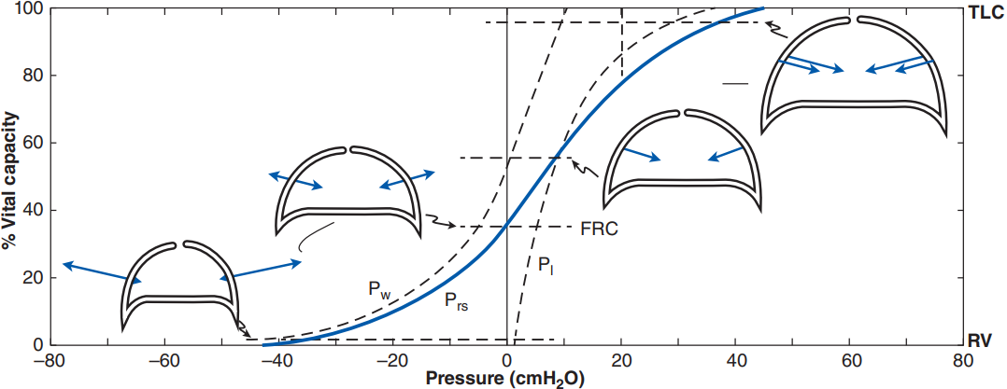**Pressure volume curve**:
  + **Functional residual capacity** vs total lung capacity vs residual volume
  + => chest wall, => lung, => respiratory system
  + The lung “wants” to collapse (>0):
    - Elastic recoil: pulmonary tissues have many elastin fibres
    - Surface tension of liquid lining inside => 70%, tested with saline
* **Alveoli**:
  + Type I (lining, very thin) vs type II (membrane embedded) alveolar cells
  + *Collapsing pressure = 2surface tension/radius; prevent smaller alveoli collapse
    - Chart, histogram

      Description automatically generated**Pulmonary surfactant**: secreted by type II, reduces surface tension (reduce more for small radius)
    - **Alveolar interdependence**: structurally supported by neighbouring ones
* **Pneumothorax**: air enters the pleural space, lung collapse (no pressure gradient)
* **Diagram

  Description automatically generated**\***Alveoli pressure**: alveolar pressure = lung recoil p + pleural pressure
  + Boyle’s law:
  + **Inspiration** (inhalation): uses **inspiratory muscles**
    - pleural pressure , alveolar pressure < ATP
    - As lung get filled lung recoil pressure , alveolar pressure => ATP
    - **Accessory inspiratory muscles** => deeper inspirations
  + **Passive expiration** (exhalation): simply relax inspiratory muscles
    - pleural pressure , alveolar pressure > ATP
    - As lung empties lung recoil pressure , alveolar pressure => ATP
  + **Active expiration**: actively reduce pleural space using **abdominal muscles**
    - 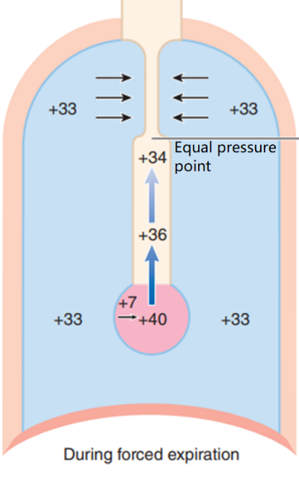pleural pressure , alveolar pressure > ATP
    - 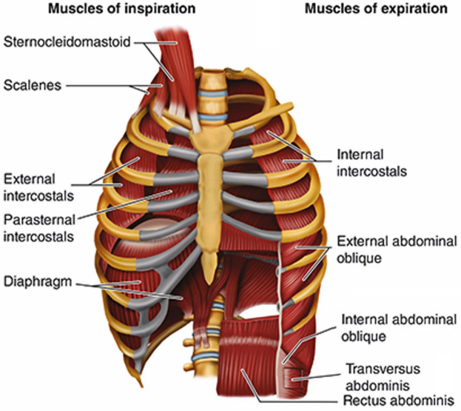Diagram

      Description automatically generated**Equal pressure point**: airway compressed (blocked)
* Bronchoconstriction vs bronchodilation
* **Diagram

  Description automatically generatedDiagram

  Description automatically generated**\***Spirometer** measures lung volumes, generates **spirogram** (average shown below)
  + *Forced expiratory volume in one second (): volume of air expired during first second of maximal expiratory effort starting from TLC
    - Usually expressed as ratio of /VC (what % can be expired in 1 s)
    - Can be used to distinguish obstructive vs restrictive diseases
  + **Chart

    Description automatically generatedExpiration** is more important because it is limiting (+resistance & length-tension)
* **Diagram

  Description automatically generated**\***Alveolar ventilation**:
  + Minute ventilation (, expiratory) = * respiratory frequency ()
  + \***Alveolar dead space** () ~ 150 mL, critical to alveolar ventilation ()
  + As ventilatory demand increases, increases first, then increases

12. 3 Gas Exchange *

* Diffusion at alveolar–capillary membrane, depends on partial pressure gradient and resistance to diffusion (SA & T)
  + Graphical user interface, text

    Description automatically generatedText, letter

    Description automatically generatedA screenshot of a computer

    Description automatically generated with low confidence**Partial pressure gradient**: Dalton’s law – partial pressure percentage in air

**100 40**

**40 46**

* + Fick’s law of diffusion: rate depends on SA and T, ~constant in healthy & rest
  + Blood also has partial pressure depending on percentage dissolved
    - 20 times more soluble than , accounts for much lower gradient
  + Capillary transit time: when blood is in pulmonary capillaries (exposed to alveoli)
  + **Ventilation** (gas exchange, facet) and **perfusion** (blood supply, drain)
    - Ventilated not perfused => alveolar dead space
    - Perfused not ventilated => shunts, anatomic dead space
  + **Vasoconstriction when low** , direct blood to better supplied alveoli
    - Low to no vasodilation, can’t be higher than normal
  + **Bronchoconstriction when low , vise versa**, more efficient gas exchange
  + Gas exchange in systemic capillaries: consistent (always a slight gradient, never reaches equilibrium), pressure gradient depends on rate of metabolism

12.4 Gas Transport (Haemoglobin) *

* Oxygen poorly soluble, need to be bound to haemoglobin (does NOT contribute to !)
* Reduced haemoglobin (deoxyhaemoglobin) vs oxyhaemoglobin
* Each haemoglobin molecule carries up to 4
* Chart, diagram

  Description automatically generatedHaemoglobin saturation (%) depends on
* Heat, carbon dioxide, and lactic acid enhance the release of oxygen
* High affinity for carbon monoxide
* (5-10%) also bounds to , most converted to bicarbonate (8-90)

12.5 Control of Breathing

* Respiratory muscles => skeletal muscles => contract only when stimulated
* *Rhythmic pattern established by **respiratory control centers** (specifically the medulla)
  + Generation of the alternating inspiratory/expiratory rhythm
    - * Dorsal respiratory group (DRG) contains primarily inspiratory neurons
      * Contract diaphragm for ins, relax for ex
    - * Ventral respiratory group (VRG) contains both, for exercise
      * Open upper airway for ins, contract to squeeze air out for ex
    - Pre-Bötzinger complex contains pacemaker-like neurons
    - Apneustic centre - associated with prolonged and deep inspirations
    - Pneumotaxic centre – associated with prolonged expirations
  + Regulation of the level of ventilation (rate & depth of breathing) by receptors
    - \***Pulmonary receptors** (mechanical):
      * **Slowly adapting receptors**: smooth muscle of airway; triggered by inflation of lung, tonic; responsible for **Breuer–Hering reflex**
        + Inflation of lung => prolonged expiration, vise versa
        + normal anesthesia, in light anesthesia can be opposite
      * Rapidly adapting receptors: epithelia of larger airways, phasic, frequent fire in response to irritants, lead to coughs and sighs
      * C-fibres: pulmonary capillaries, detect increases in arterial pressure, cause bronchoconstriction & rapid shallow breathing
    - \***Chest wall receptors** (mechanical):
      * Many small sensors, lack myelination
      * Diaphragm: few protective receptors (coughing, sneezing, …)
      * Rib cage: rich in spindle receptors, attempt to meet contractile expectations and stabilizes thorax
    - *Chemical: effect of arterial oxygen and carbon dioxide
      * **Peripheral chemoreceptors**: respond to oxygen
        + **Carotid bodies**: ventilation when
        + **Aortic bodies**: cardiac output when oxygen content
      * 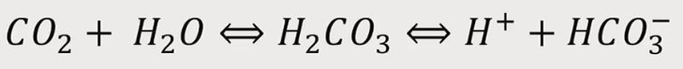**Central chemoreceptors**: respond to
        + Very sensitive to partial pressure
        + Respond to pH ( induce changes, slower)
        + Regulates resting ventilation (most important factor)
  + Graphical user interface, text

    Description automatically generatedText

    Description automatically generatedModificati­on of respiratory activity to serve other purposes (voluntary, as in speech, or involuntary, as in cough or sneeze)
* Apnea: transient interruption of ventilation, breathing resuming spontaneously
  + Respiratory arrest: if breathing does not resume
* Dyspnea: breathlessness

